**Kurenkov Nikita Homework1 mol-syst-bio**

**Task 1**

1. 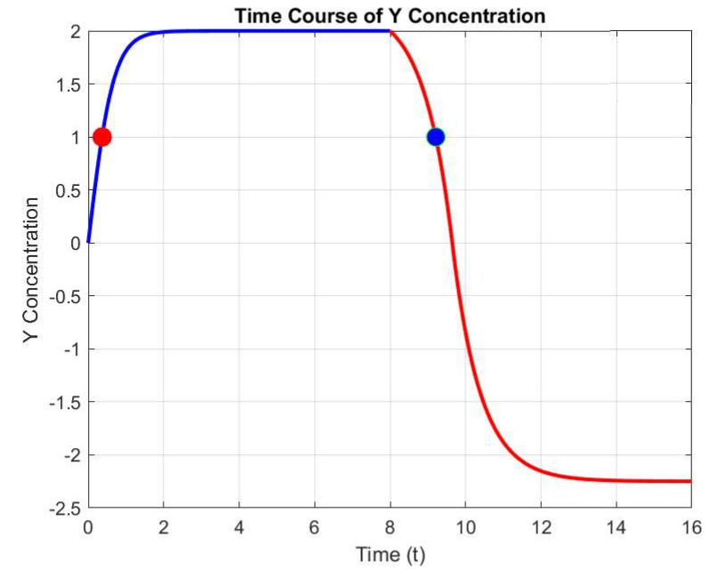**b = 3**

T1 (Y activates Z): 0.36959

T2 (Y represses Z): 9.211 (in 1.211 total)

1. b = 2.1 (30% decrease)

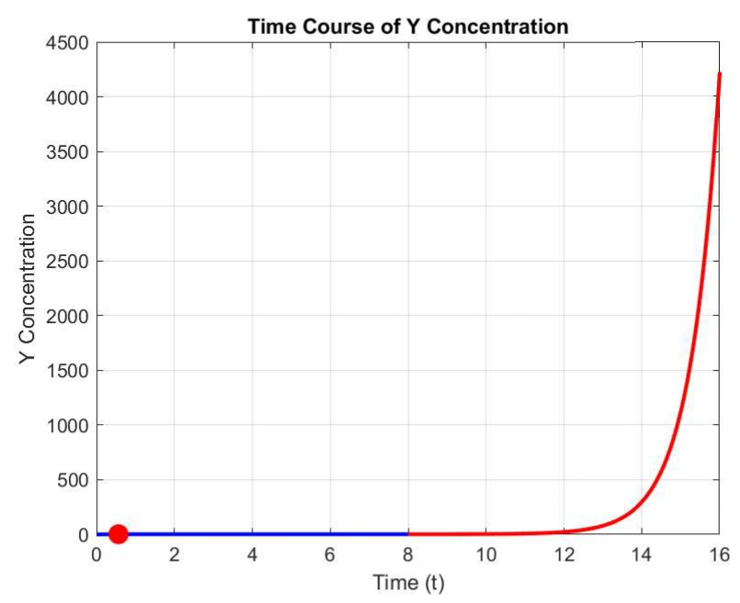

T1 (Y activates Z): 0.56238

T2 (Y represses Z):

1. b = 3.9 (30% increase)

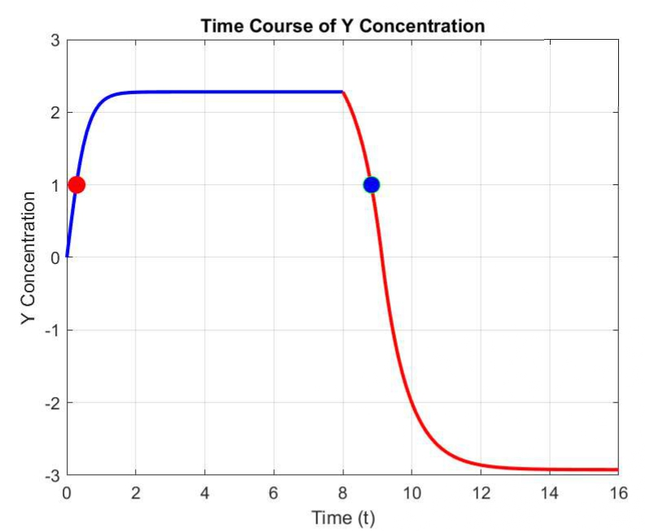T1 (Y activates Z): 0.28532

T2 (Y represses Z): 8.8318 (in 0,8318 total)

T1 (Y activates Z) appears to be more robust to fluctuations in the production rate (b) compared to T2 (Y represses Z). When b decreases by 30%, T2 becomes undefined (no activation below the threshold). This indicates that a decrease in production rate can lead to situations where the threshold is never crossed, meaning there's no activation of Z in the secondary mechanism. When b increases by 30%, T2 experiences a smaller change (0.8318). This means that an increase in the production rate still allows for the activation of Z in the secondary mechanism, although it occurs slightly earlier than the reference case. T1 is more robust because it consistently activates Z, even in the face of fluctuations in the production rate, while T2 may become less reliable and, in some cases, not applicable when production rate decreases. The robustness of T1 can be attributed to the fact that it relies on the primary mechanism (Y activates Z) and is less affected by changes in production rate, whereas T2 (Y represses Z) is more sensitive to such changes.